Adverbs of Manner

🔹 What Are Adverbs of Manner?
# Source: AI Source: Provided by: [Data Path: Persons Table -> ID Column: 1, Name_En Column: Motasem Essam] -> From: [Chatgpt (GPT-4-turbo)] on [7/27/2025]
Adverbs of manner describe how an action is performed.
They usually modify a verb and often answer the question: 👉 "How?"

✅ Common Adverbs of Manner
# Source: AI Source: Provided by: [Data Path: Persons Table -> ID Column: 1, Name_En Column: Motasem Essam] -> From: [Chatgpt (GPT-4-turbo)] on [7/27/2025]
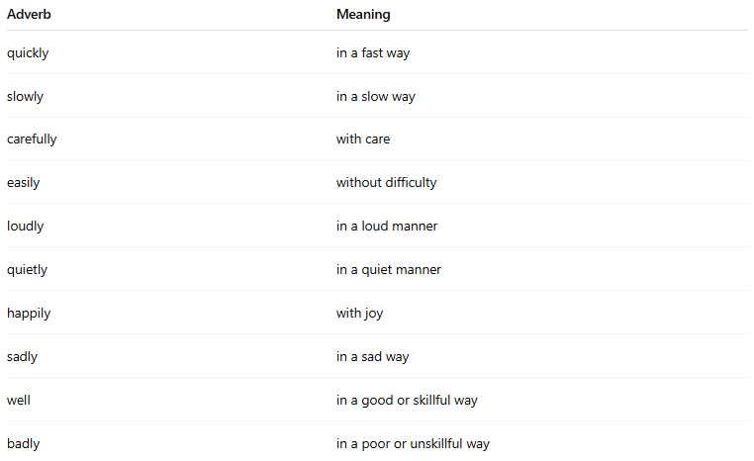
Adverb | Meaning
quickly | in a fast way
slowly | in a slow way
carefully | with care
easily | without difficulty
loudly | in a loud manner
quietly | in a quiet manner
happily | with joy
sadly | in a sad way
well | in a good or skillful way
badly | in a poor or unskillful way

📚 Examples in Sentences
# Source: AI Source: Provided by: [Data Path: Persons Table -> ID Column: 1, Name_En Column: Motasem Essam] -> From: [Chatgpt (GPT-4-turbo)] on [7/27/2025]
- She speaks clearly.
- He runs quickly.
- They worked hard all day.
- The baby slept peacefully.
- Please listen carefully.

🧠 Key Notes
# Source: AI Source: Provided by: [Data Path: Persons Table -> ID Column: 1, Name_En Column: Motasem Essam] -> From: [Chatgpt (GPT-4-turbo)] on [7/27/2025]
- Most are formed by adding -ly to an adjective:
slow → slowly, quiet → quietly
- Some do not follow the -ly rule:
fast, well, hard (these are irregular adverbs of manner)
- They usually come after the verb or after the object:
✅ She answered the question correctly.
✅ He spoke softly.

